Lab – 1: Linear Search and Binary Search
git repo: https://github.com/Praneeth0910/DAA-CSE204
Name: Baratam Praneeth Gupta
Admission Number: AP25110010120
Subject code: CSE 204
Task -1 : Linear search
Source code:
#include <stdio.h>

int linearsearch(int a[], int n, int target) {
for (int i = 0; i < n; i++) {
if (a[i] == target) {
return i;
}
}
return -1;
}

int main() {
int n;

printf("Enter the number of elements: ");
scanf("%d", &n);

int a[n];

printf("Enter the elements:\n");
for (int i = 0; i < n; i++) {
printf("Element %d: ", i + 1);
scanf("%d", &a[i]);
}

int target;
printf("Enter the element to search: ");
scanf("%d", &target);

int result = linearsearch(a, n, target);

if (result != -1)
printf("Element found at index %d\n", result);
else
printf("Element not found.\n");

return 0;
}

Outputs: both the cases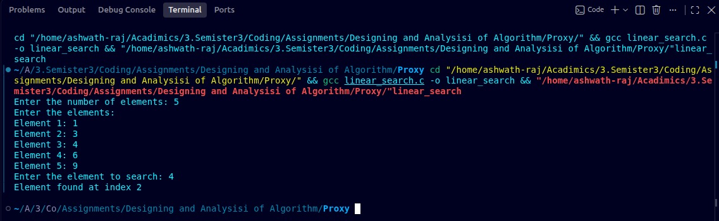
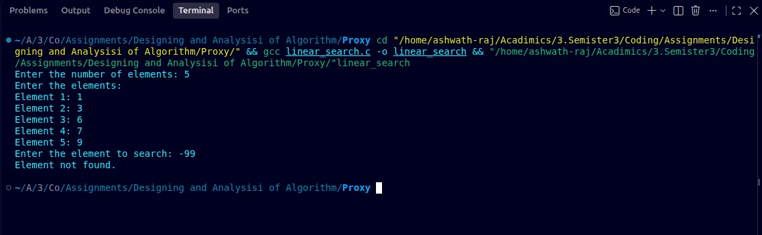
Task – 2 – Binary Search
Source code:
#include <stdio.h>

void bubbleSort(int arr[], int n) {
int i, j, temp;
for (i = 0; i < n - 1; i++) {
// Last i elements are already in place
for (j = 0; j < n - i - 1; j++) {
if (arr[j] > arr[j + 1]) {
// Swap arr[j] and arr[j+1]
temp = arr[j];
arr[j] = arr[j + 1];
arr[j + 1] = temp;
}
}
}
}
int binarysearch(int a[], int n, int target) {
int low = 0;
int high = n - 1;

while (low <= high) {
int mid = low + (high - low) / 2;

if (a[mid] == target)
return mid;

if (a[mid] < target)
low = mid + 1;
else
high = mid - 1;
}

return -1;
}

int main() {
int n;

printf("Enter the number of elements: ");
scanf("%d", &n);

int a[n];

printf("Enter the elements:\n");
for (int i = 0; i < n; i++) {
printf("Element %d: ", i + 1);
scanf("%d", &a[i]);
}

bubbleSort(a, n);

printf("\nArray after Bubble Sort:\n");
for (int i = 0; i < n; i++) {
printf("%d ", a[i]);
}
printf("\n\n");

int target;
printf("Enter the element to search: ");
scanf("%d", &target);
int result = binarysearch(a, n, target);

if (result != -1)
printf("Element found at index %d\n", result);
else
printf("Element not found.\n");

return 0;
}
Output: both the cases